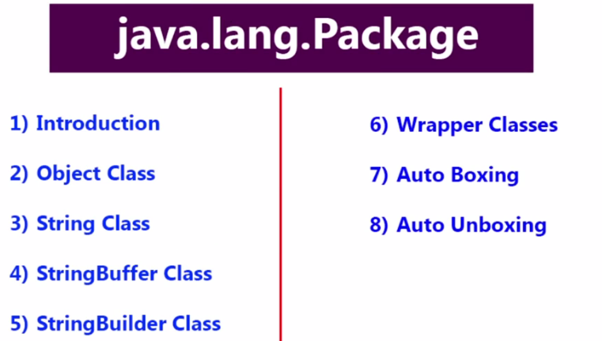

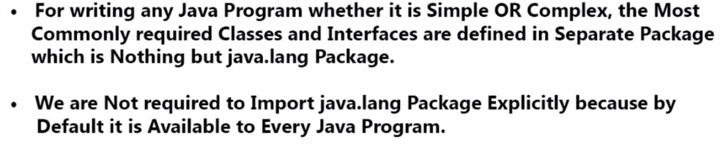

The most commonly required methods for every Java class (whether it is predefined or customized class) are defined in a separate class which is nothing but Object class. Every class in java is the child class of Object either directly or indirectly. So that Object class methods by default available to every java class. Hence Object class is considered as root of all java classes.

If our class does not extend any other class then only our class is the direct child class of object.

If our class extends any other class then our class is indirect child class of Object.

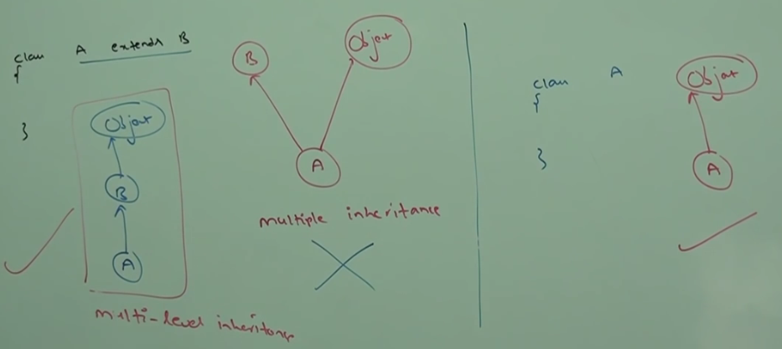

Either directly or indirectly Java won’t provide support to multiple inheritance with respect to classes.

Object class defines the following 11 methods:

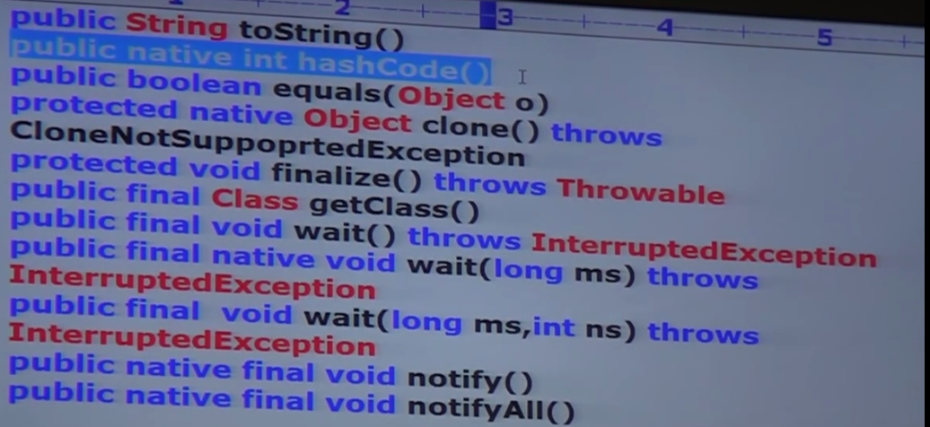

**registerNatives** is the 12th method:

This method is internally required for Object class and not available to child classes.

**toString**: We can use toString method to get String representation of an Object. Whenever object referenced is printed internally toString method will be called.

Ex: String s = obj.toString();

Student st = new Student ();

Sop(st.toString());

If our class does not contain toString method then Object class toString method will be executed.

**How Object Class toString method is implemented:**

Object class toString () method is implemented as follows:

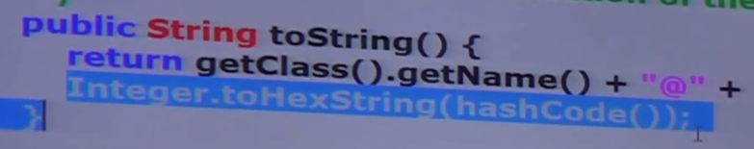

className@hash_code_in_hexadecimal_form

We can override the toString method of object in the class as follows:

Public String toString () {

return ……;

}

In all Wrapper class, Collection class, String Class, String Buffer and String Builder classes toString () method is overridden for meaning String representation.

Hence, it is highly recommended to override toString () in our class.

**Hash Code Method:**

For every Object a unique is generated by JVM (Which is nothing but Hash Code). Hash Code won’t represent address of Object. JVM will use Hash Code while saving Objects into hashing related data Structures like:

1. HashTable
2. HashMap
3. HashSet

Advantage of saving objects based on hash code is search operation will become easy (Most powerful search algorithm up to today is Hashing).

**Override Hash Code:**

Object class hash code method generates hash code based on address of object. It does not mean hash code represents address of the object.

Based on our requirement we can override hash code method in our class to generate our own hash code.

Overriding hash code method is said to be proper if and only if for every object we must generate a unique number as hash code.

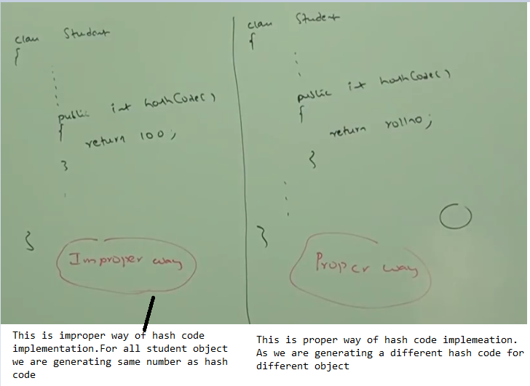

**toString vs Hashcode:**

Object class toString method internally calls hash code methods.

If a class overrides toString method, then the toString method may not call hash code method.

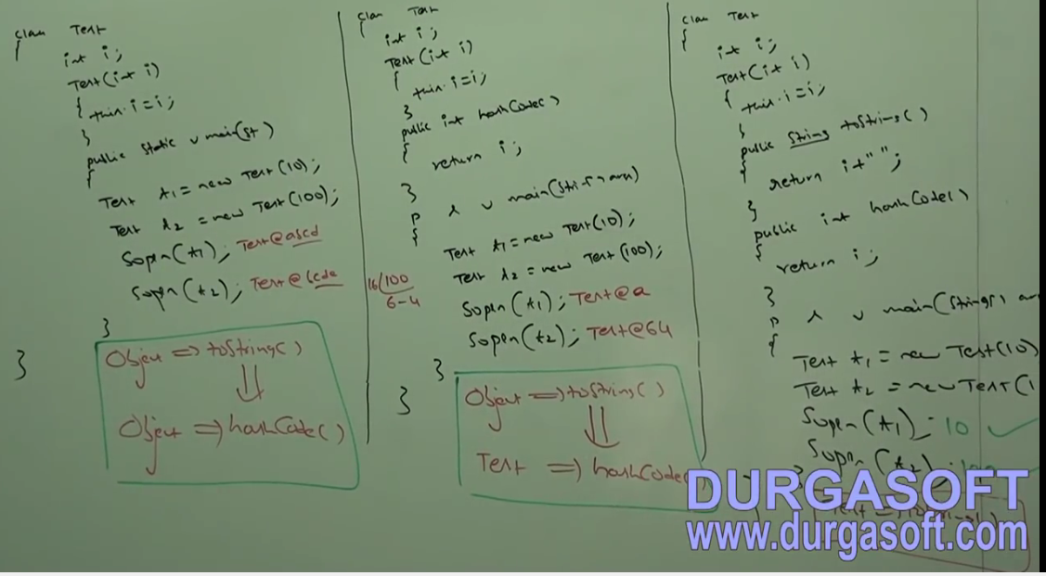

**Equals method:**

We can use equals method to check equality of 2 objects.

Ex: obj1.equals(obj2);

If our class does not contain equals method then Object class equals method will be executed.

== 🡪 Reference comparison

.equals () 🡪 Content comparison

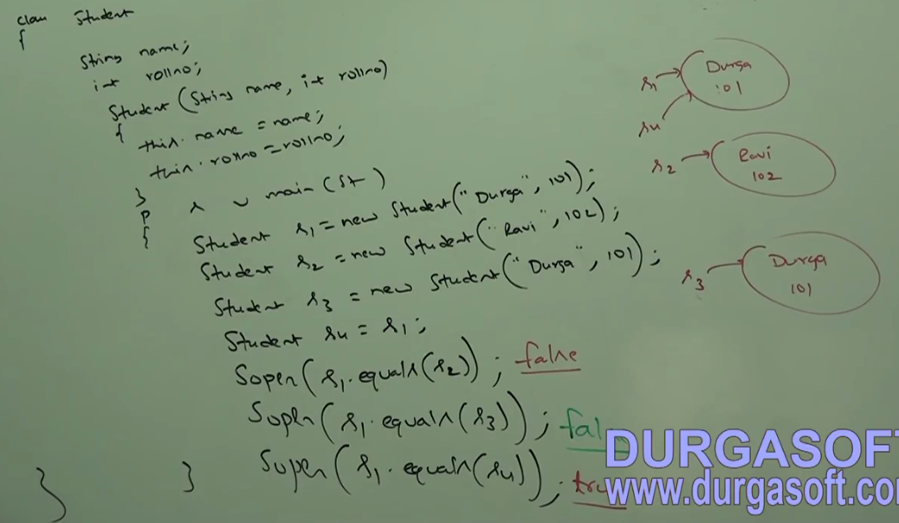

In the above example Object class equals method got executed which is meant for reference comparison (address comparison i.e. if two references pointing to the same object then only equals () method returns true).

Based on our requirement we can override equals method for content comparison.

While overriding equals method for content comparison we should take care of the following:

1. What is the meaning of equality i.e. (Weather we must check only names or roll numbers or both)
2. If we are passing different types of object then our equals method should not raise ClassCastException. We must handle ClassCastException to return false;
3. If we are passing null argument then our equals method should not raise NullPointerException i.e. we must handle null pointer exception to return false.

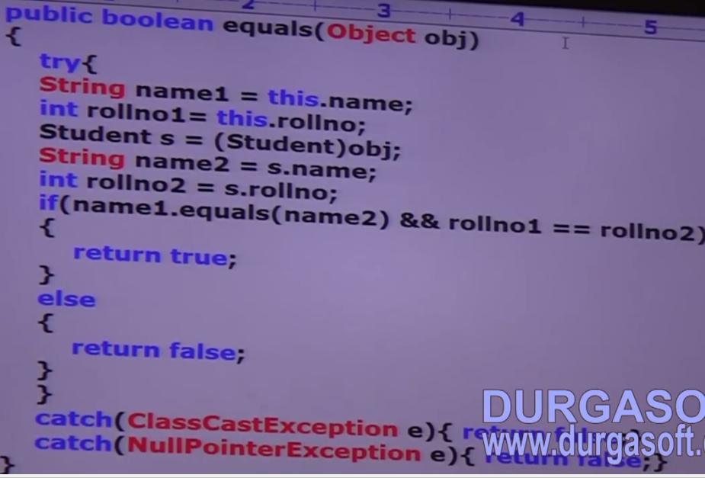

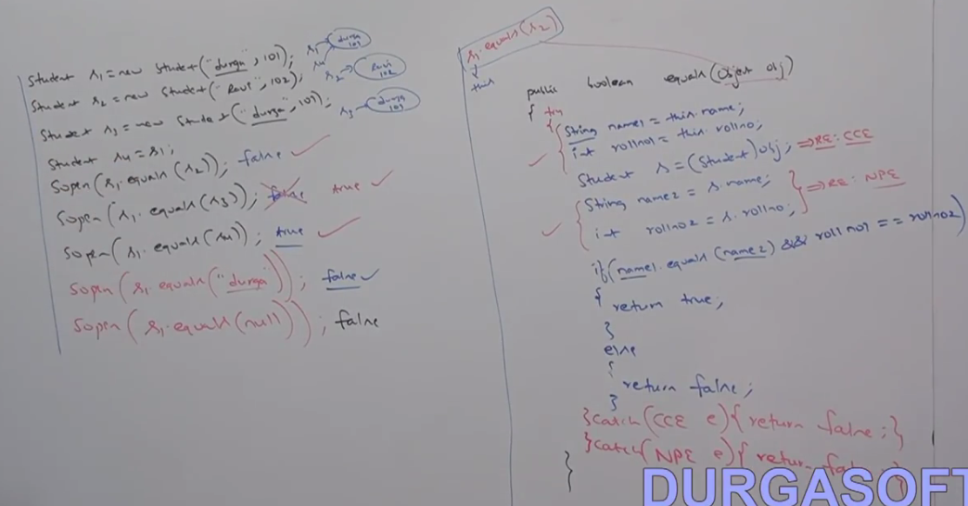

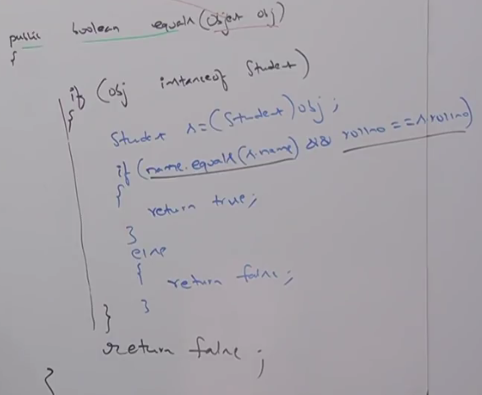

To make above equals method more efficient we can write following code at the beginning inside equals method.

If (obj == this) {return true;}

If both references pointing to same object then, without performing any comparison equals method return true directly.

**Default behavior of equals method is reference comparison. We can override it for content comparison.**

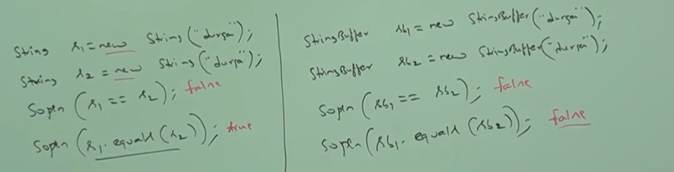

**In String Class “.equals” method is overridden for content comparison. Hence, even though objects are different if content is same then “.equals” method returns true.**

**In StringBuffer “.equals” method is not overridden for content comparison. Hence, if objects are different “.equals” method returns false even though content is same.**

**getClass ():**

--------------------

To get run time class definition of an Object.

Public final Class getClass ()

By using Class Class Object, we can access class level properties.

1. Fully Classified name of class.
2. Method information’s

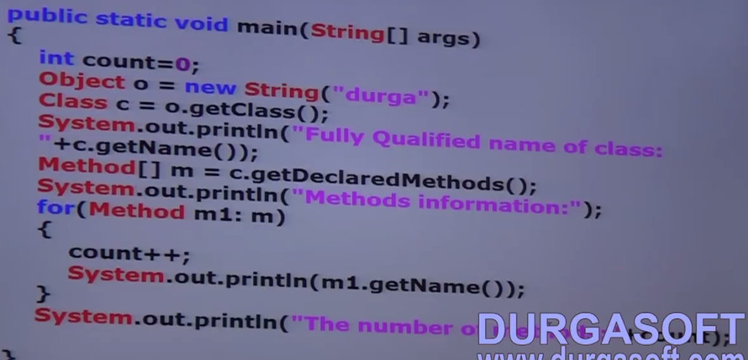

**Display Vendor Specific Connection Interface Implemented Class Name:**

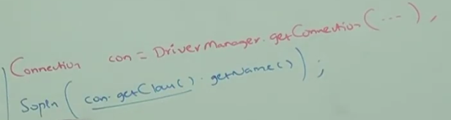

**Note*:** For every loaded class file JVM will create an Object in the heap area.

After loading every class file JVM will create an Object of the type “java.lang.class” in the heap area.

Programmer can use this class object to get class level information.

We can use getClass method very frequently in Reflection API.

**Finalize**: Just before destroying the object garbage collector calls finalize method to perform cleanup activities. Once finalize method completes automatically garbage collector destroys that object.

**Wait, Notify, NotifyAll ()**

We can use these methods for inter thread communication. The thread which is expecting updation will call wait method. Immediately thread will enter to waiting state. The thread which is responsible to perform updation, after performing updation the thread can call notify method. The waiting thread will get that notification and continue its execution with those updates.

**String**: **Case1**

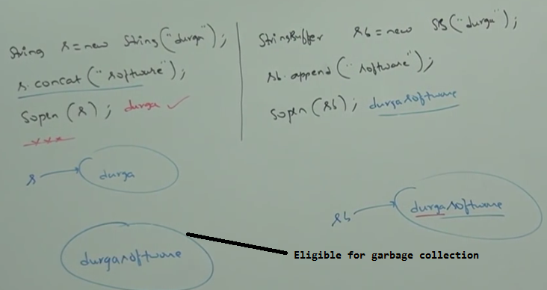

**Case2:**

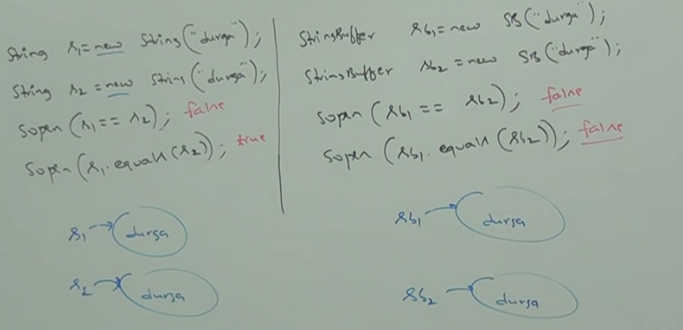

**In String Class “.equals” method is overridden for content comparison. Hence, even though objects are different if content is same then “.equals” method returns true.**

**In StringBuffer “.equals” method is not overridden for content comparison. Hence, if objects are different “.equals” method returns false even though content is same. As in the Object class equals method is mean for reference comparison.**

**Case3:**

1. String s = new String (“durga”);

In this case 2 objects will be created. One in the heap area and the other in SCP (String Constant Pool). “s” is always pointing to Heap Object.

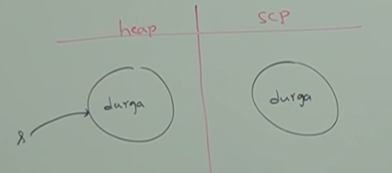

1. **String s = “durga”**

In this case only one object will be created in String Constant Pool and “s” is always pointing to that Object.

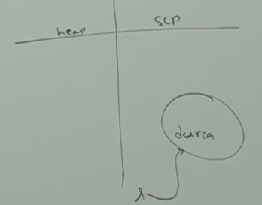

Object creation in SCP is optional. First it will check is there any Object already present in SCP with required content. If Object already present then existing object will be reused. If the object is not available in the SCP then only a new Object will be created. This rule is applicable only for SCP (String Constant Pool) but not for heap.

Garbage collector is not allowed to access SCP area. Hence, even though Object does not reference variable it is not eligible for GC if it is present in SCP area. SCP area is part of Method Area.

**Garbage collector can access only heap area.**

All SCP objects will be destroyed automatically at the time of JVM shutdown.

**Case4**: In the below example total 3 objects will be created.

**Whenever we are using new operator a new object will be created in the heap area every time**. Hence, there may be a chance of existing 2 objects with same content in the heap area but not in SCP (String Constant Pool).

Duplicate Objects are possible in the heap area. But not in SCP.

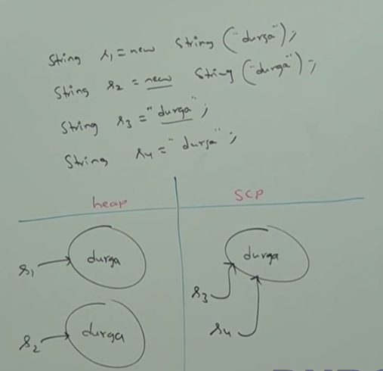

**Case5: Very Very Very Important**

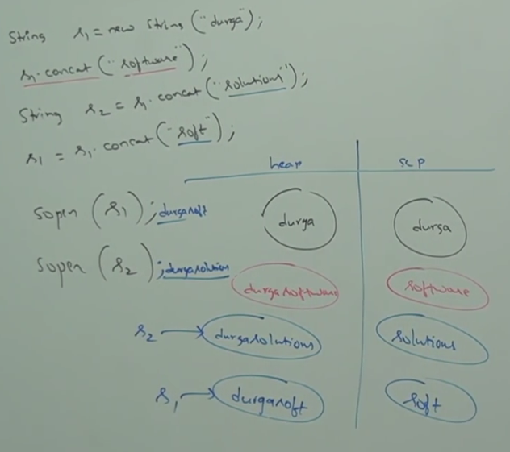

In the above example total 8 objects will be created. 4 in heap area and 4 in SCP.

**Note*:**

1. For every String Constant 1 Object will be placed in SCP area.
2. Because of some runtime operation if an Object is required to be created, that object will be placed only in the heap area but not in SCP area.

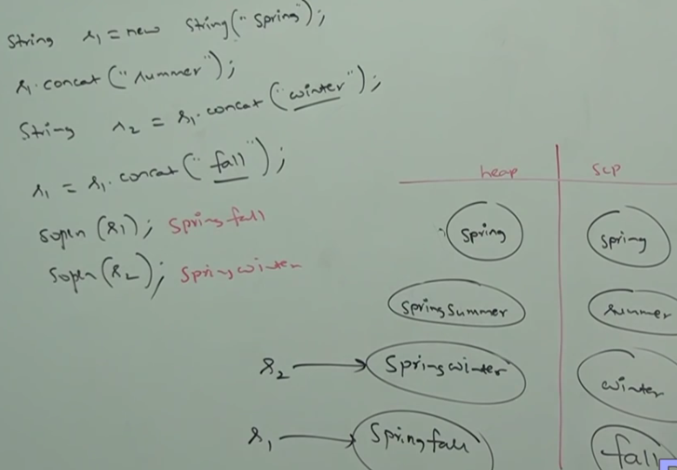

1. String s = new String ();

Creates an empty String Object.

1. String s = new String (String literal);

Creates a String object with given String literal.

1. String s = new String (StringBuffer sb);

Creates an equivalent String Object for given String Buffer.

1. String s = new String (Char [] chArr);

Char[] chArr = {‘a’,’b’,’c’,’d’};

String s = new String (chArr);

S===abcd

Creates an equivalent String Object for given character array.

1. String s = new String (byte [] bArr);

byte[] bArr = {100,101,102,103}

String s = new String (bArr);

S===defg

Creates an equivalent String Object for the given byte array.

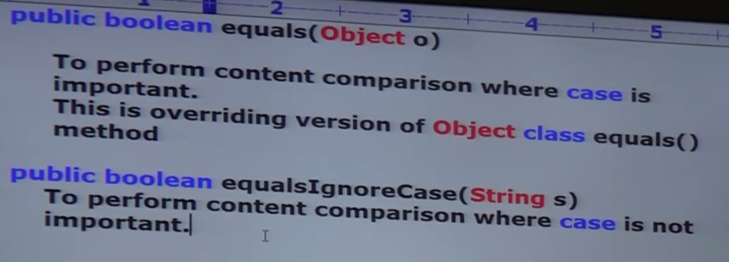

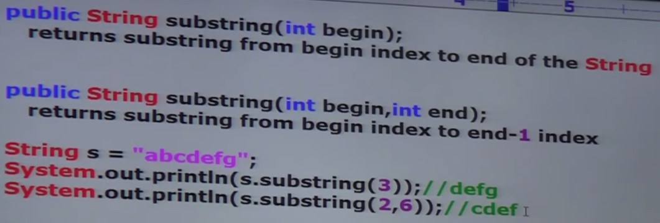

**Note****:** Because of runtime operation if there is a change in the content then with those changes a new Object will be created in the Heap Area. If there is no change in the content then existing object will be reused and new Object won’t be created.

Weather the object presents in heap or scp the rule is same.

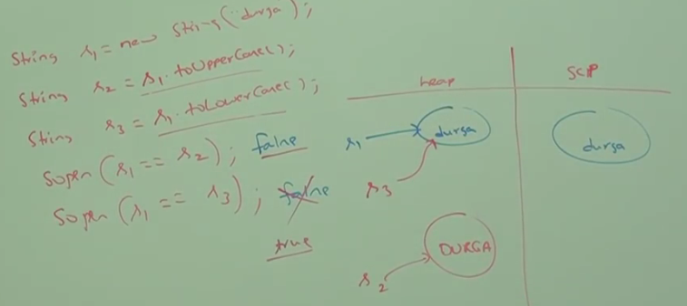

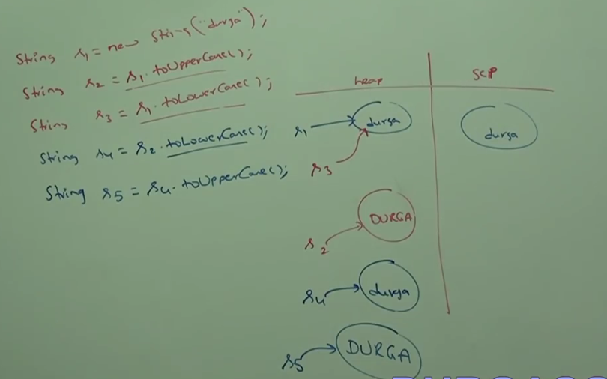

**Very Important Concept**

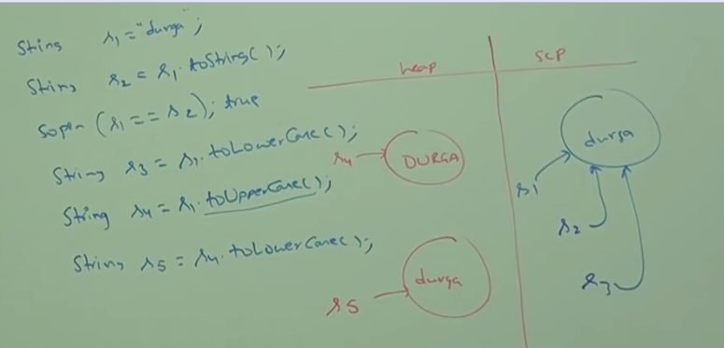

**How to create our own Immutable Class:**

Once we create an object we can’t perform any changes in that Object. If we are trying to perform any change (and if there is a change in the content) then with those changes an Object will be created.

If there is no change in the content then existing Object will be reused.

This behavior is nothing but Immutability.

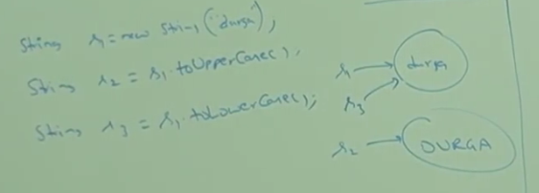

We can create our own immutable class🡪

Once we create a test object we can’t perform any change in the existing Object. If we are trying to perform any change and if there is a change in the content, then with those changes a new Object will be created.

If there is no change in the content then existing Object will be reused.

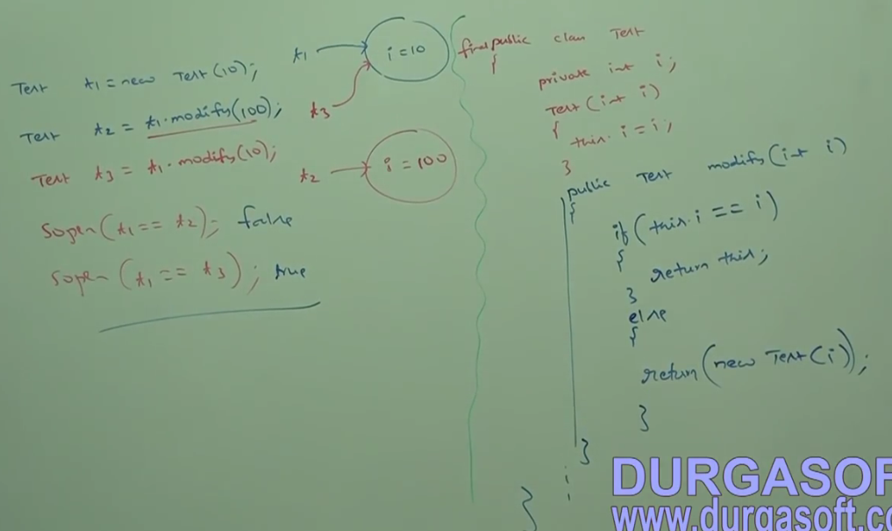

**Final vs Immutability:**

Final applicable for variables but not for Objects. Whereas, immutability applicable for Objects but not for variables.

By declaring a reference variable as final we won’t get immutability nature. Even though reference variable is the final we can perform any type of change in the corresponding object. We can’t perform reassignment for that variable.

Final and Immutable both are different concepts.

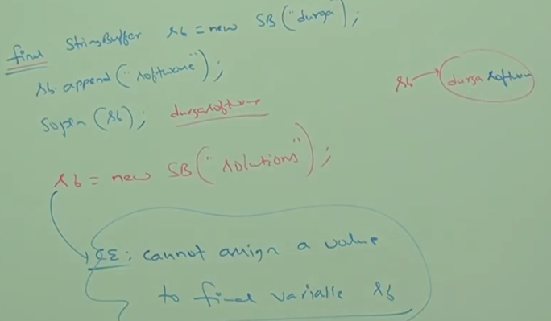

**String Buffer**:

If the content is fixed and won’t change frequently then it is recommended to go for String. If the content is not fixed and keep on changing then it is not recommended to use String. Because for every change a new Object will be created which affects performance of the System. To handle this requirement, we should go for String Buffer.

Advantage of String Buffer over String is all required changes will be performed in the existing object only.

1. StringBuffer sb = new StringBuffer();

Creates an empty String Buffer Object with default initial capacity 16. Once it reaches max capacity a new StringBuffer Object will be created with new capacity = (currentCapacity+1) *2

1. StringBuffer sb = new StringBuffer (int initCapacity)

Creates an empty String Buffer Object with specified initial capacity.

1. StringBuffer sb = new StringBuffer (String s)

Creates an equivalent String Buffer for the given String with capacity as:

Capacity = s.length()+16

Ex: StringBuffer sb = new StringBuffer(“durga”);

Capacity = 5+16 =21

**Important methods of String Buffer:**

Public StringBuffer append (String|int|long|char|float|double val)

Public StringBuffer insert (String|int|long|char|float|double val)

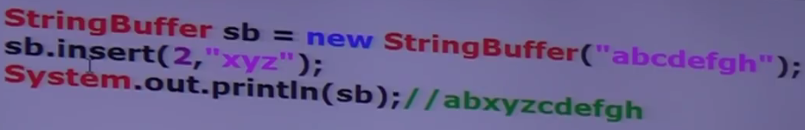

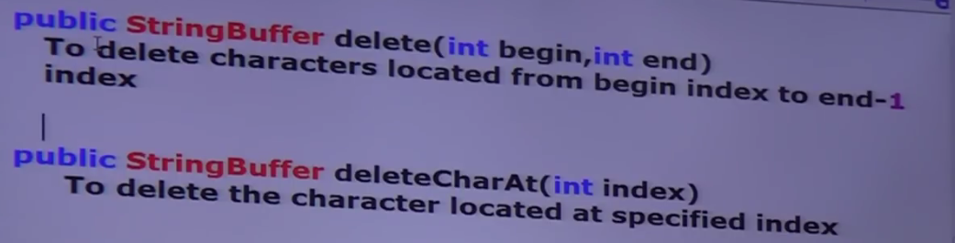

Method to reverse a String:

Sb sb =new SB(“bishwa”);

Sopln (sb.reverse());🡪awhsib

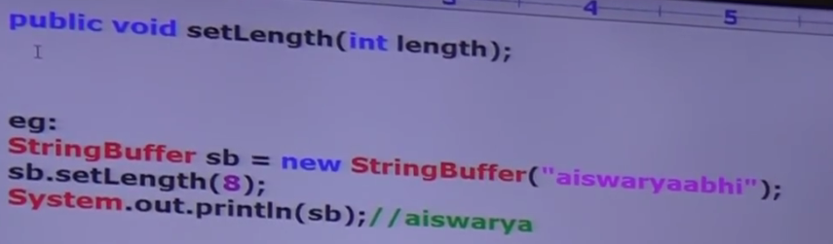

To increase capacity on fly based on the requirement:

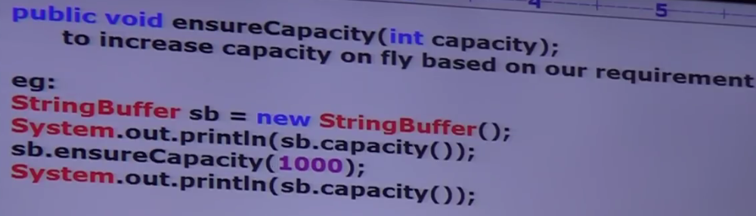

To decrease capacity of the String Buffer

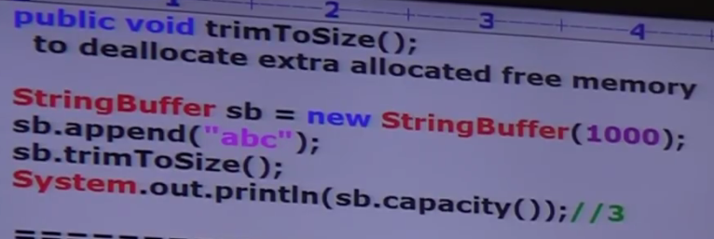

**StringBuilder:**

Every method in StringBuffer is synchronized. Hence, only one thread can operate on StringBuffer object at a time which may create performance problems. To handle this StringBuilder concept is introduced in 1.5 version.

1. All the methods in StringBuffer—Synchronized. Whereas all the methods in StringBuilder is non-synchronized.
2. At a time only one thread can operate on StringBuffer. Hence it is thread safe.

Multiple threads can operate on StringBuilder Object. So, it is not thread safe.

1. Threads are required to wait to operate on StringBuffer object. Hence performance is low. However, threads are not required to wait on StringBuilder. So, performance is high.
2. StringBuffer introduced in 1.0. StringBuilder in 1.5

**String vs StringBuffer vs StringBuilder**

**------------------------------------------------**

1. If the content is fixed and won’t change frequently then we should go for String.
2. If the content is not fixed and keep on changing. But thread safety is required then we should go for StringBuffer.
3. If the content is not fixed and keep on changing. But thread safety is not required then we should go for StringBuilder
4. If 2 objects are equal by == operator then these objects are always equal by. Equals () method.

If r1==r2 is true then r1. equals(r2) is always true.

1. If 2 objects are not equal by == operator. Then we can’t conclude from. equals() method. It may return true or false.
2. If 2 objects are equal by “.equals()” then we can’t conclude anything from == method.

If r1.equals(r2) is true the r1==r2 may return true or false.

1. If r1.equals(r2) is false the r1==r2 is always false.

Very Important

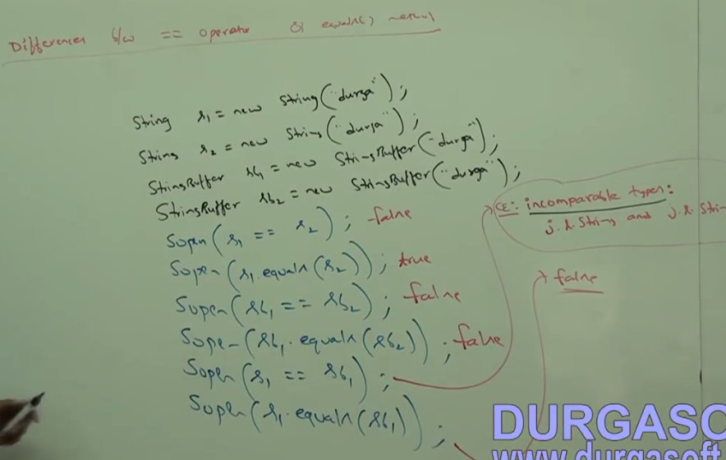

**To use == there should be relationship between the 2 types. Either Parent child or child to Parent.**

**If there is no relationship between argument types then. Equals () method won’t rise any compile time or runtime errors. Simply it returns false.**

|  |  |
| --- | --- |
| **== operator** | **Equals ()** |
| It is an operator in java applicable for both Primitive or Object | It is a method applicable only for Object types but not for primitives |
| In case of object references == operator meant for reference comparison (address comparison). | By default, Equals () method present in Object class also meant for Reference comparison. |
| Can’t override == operator for content comparison | We can override for content comparison |
| To use == operator, there should be relationship between types (Either Parent to Child or Child to Parent or same type). Otherwise compile time error Incompatible type error. | If there is no relationship between argument types then .Equals() method won’t rise any compile time or runtime errors and simply returns false. |

**Note*: == is for Reference comparison and .equals () is for content comparison**

**For any object reference r,**

**r==null and r.equals(null)-🡪False**

Hashing related data structure follow the below rules:

1. 2 equivalent objects should be placed in same bucket. But all objects present in the same bucket need not be equal.

**Contract between .Equals and hash code**

**2 equivalent Object should have same hash code.**

**If r1.equals(r2) -🡪true then r1.hashcode() == r2.hashcode()🡪Always true**

Object class .equals () and HashCode() methods above rule. So, if .equals() is overridden then hashcode () should be overridden to satisfy above contract.

If 2 objects are not equal by == method then there is no restriction on hash codes. May be equal or may not be equal.

If r1 and r2 are having same hash code 🡪 We can’t conclude anything about .equals(). It may return true or false.

In String class equals () method is overridden for content comparison. Hence, hash code method is also overridden to generate based on content.

In StringBuffer .equals() method is not overridden for content comparison. Hence, hash code method is also not overridden.

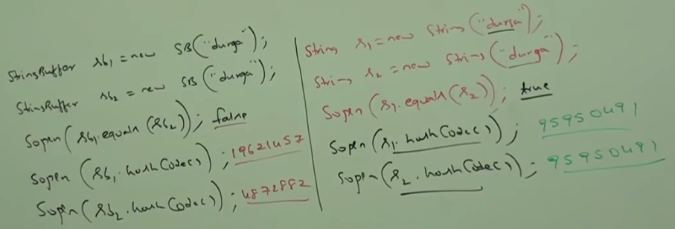

Example of Equals and Hash Code implementation in class:

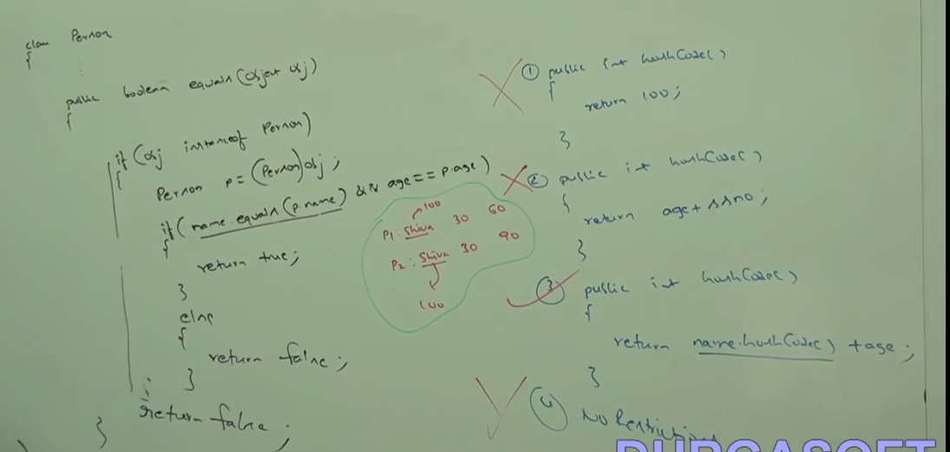

Based on the parameter we use in equals method. It is highly recommended to use it in hash code.

**In all collection, wrapper classes and in String class equals () method is overridden for content comparison. Hence, it is highly recommended to override equals() method in class also for content comparison.**

**String Object creation in Heap/ String Constant Pool**

SCP is the specially designed memory area for String Objects.

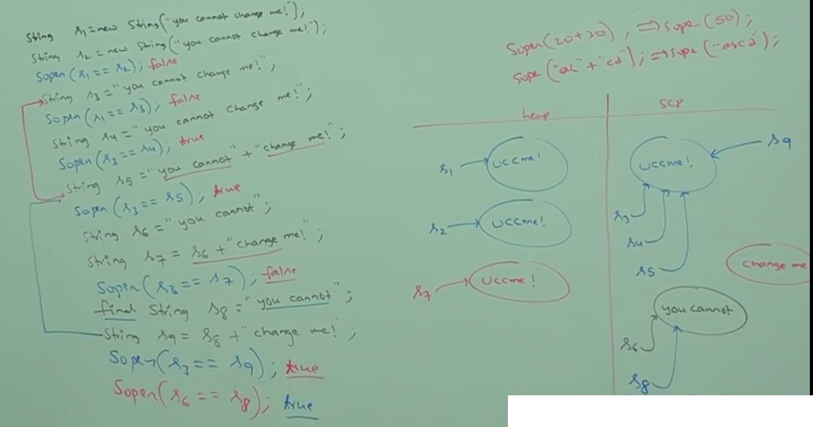

**S5 will be executed at compile time only as both arguments are compile time constants.**

**S7 will be performed at run time only because at least one argument is normal variable.**

**S9 will be performed at compile time only as both arguments are compile time constants.**

**String is the most commonly used object and hence SUN people provided special memory management for String objects. But String-Buffer is not commonly used object. Hence, special memory management is not required for String Buffer.**

In case of String because of SCP a single object can be referenced by multiple references. By using one reference if we can change the content in the existing object then remaining references will be affected. To overcome this problem SUN people implemented String object as Immutable.

According to this once a String object is created we can’t perform any changes in the existing object. If we are trying to perform any changes with those changes a new object will be created.

In String Buffer there is no concept like SCP. Hence, for every requirement a separate object will be created. By using one reference if we are trying to change the content then there is no effect on remaining references. Hence, immutability concept not required for StringBuffer.

**All Wrapper class objects also immutable in Java.**

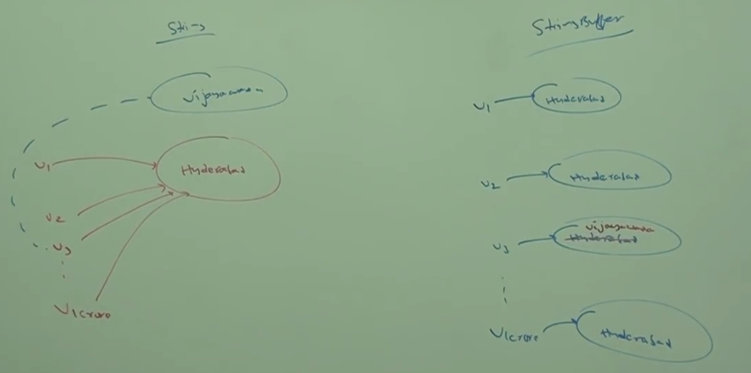

**Interning of String Object:**

By using heap object reference if we want to get corresponding SCP object reference then we should go for intern () method.

**Example:**

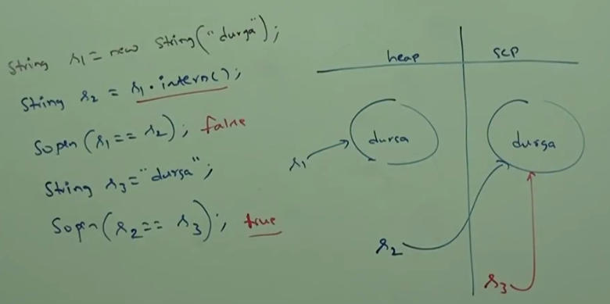

**If the corresponding SCP object is not available then intern method itself will create the corresponding SCP object.**

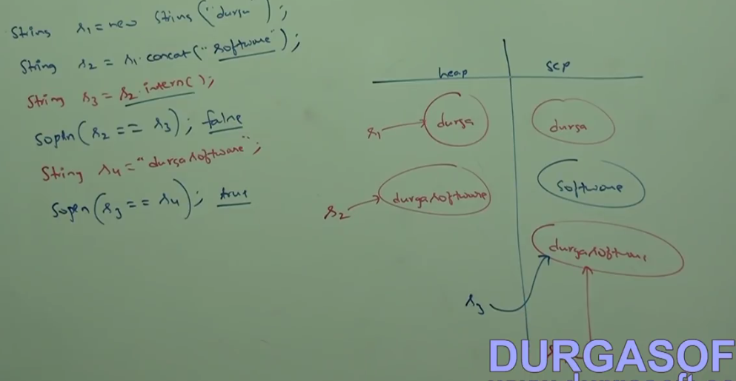

**Why String is Immutable:**

In our program if a String object is repeatedly required then it is not recommended to create separate object for every requirement. Because it creates performance and memory problems.

Instead of creating a separate object for every requirement we can create only one object and it can be reused for every requirement. So, performance and memory utilization will be improved. This is possible because of SCP. Hence, main advantages of SCP are:

1. Memory Utilization and performance will be improved.
2. Main problem with SCP is 🡪 As several references pointing to the same object, by using one reference if we are trying to change the content then remaining references will be affected. To overcome this problem SUN implemented String Objects as Immutable.
3. Once we create a String objects we can’t perform any changes in the existing object. If we are trying to perform any changes with those changes a new object will be created.

**SCP is the only reason for Immutability of String Objects.**

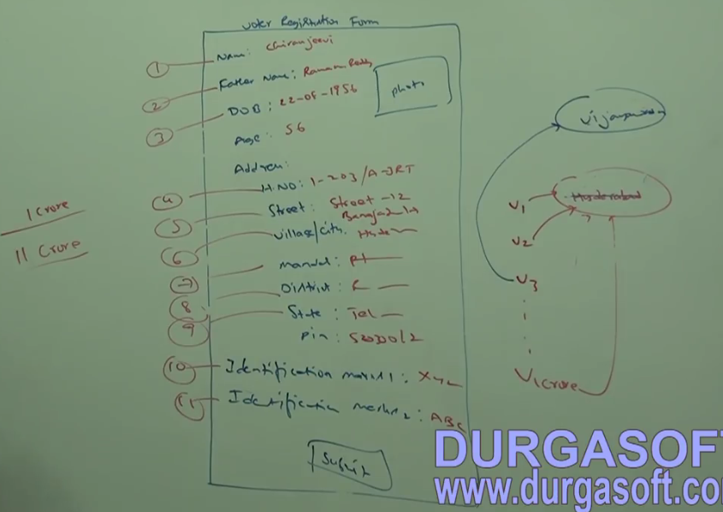

**Clone:**

The process of creating exactly duplicate object is called Cloning. Main purpose of cloning is to maintain backup copy and to preserve state of an object.

We can perform cloning by using clone method of Object class.

**Protected native Object clone () throws CloneNotSupportedException**

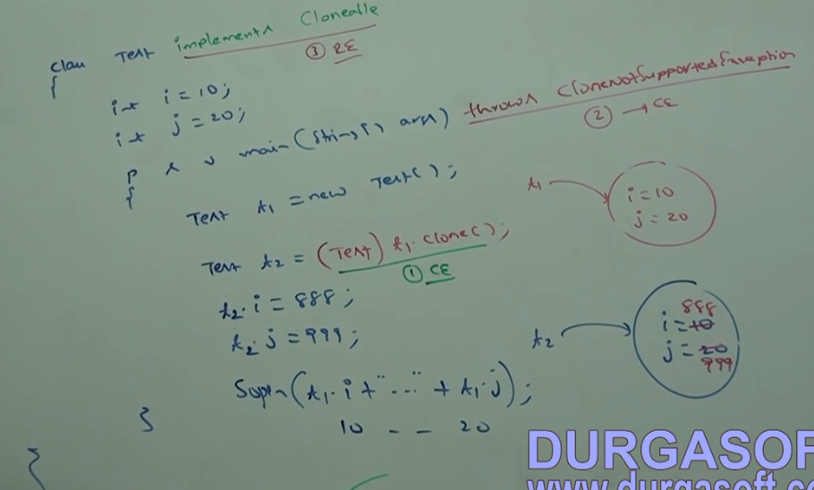

**We can perform cloning only for cloneable objects. An object is said to be cloneable if and only if the corresponding class implements Cloneable Interface.**

Cloneable interface present in java.lang package and it does not contain any methods. It is a marker interface. If we are trying to perform cloning for non-cloneable objects then we will get runtime exception saying: CloneNotSupportedException.

**Shallow Cloning and Deep Cloning:**

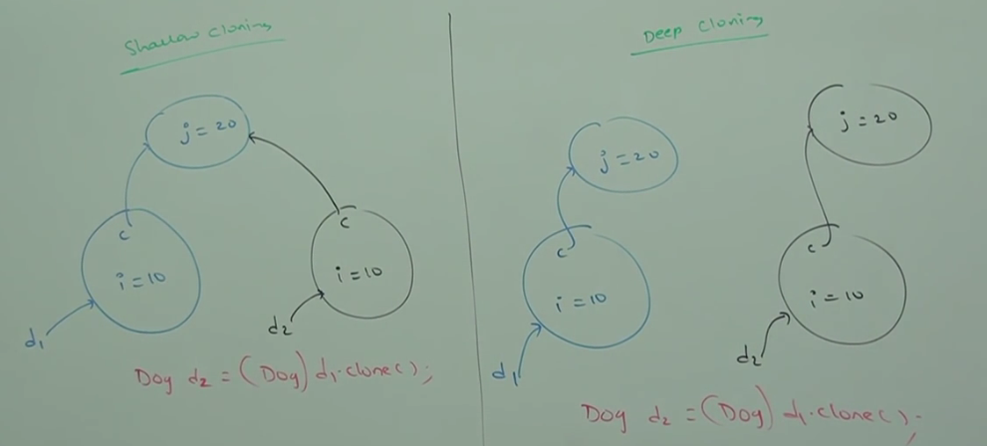

The process of creating bitwise copy of an object is called **Shallow cloning**. If the main object contain primitive variables then exactly duplicate copy will be created in the cloned object.

If the main object contains any reference variable then corresponding object won’t be created just duplicate reference variable will be created pointing to old content object.

**By default Object class clone method meant for shallow cloning**.

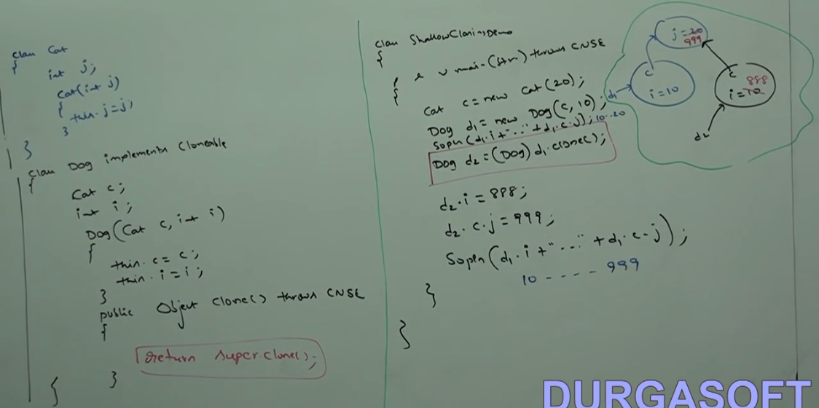

In Shallow cloning by using cloned object reference if we perform any change to the content object then those changes will be reflected to the main object. To overcome this problem, we should go for deep cloning.

**Deep Cloning:** The process of creating exactly duplicate independent copy including content object is called deep cloning. In deep cloning if the main object contains any primitive variables then in the cloned object duplicate copy will be created. If the main object contains any reference variable then the corresponding content object also will be created in the cloned copy.

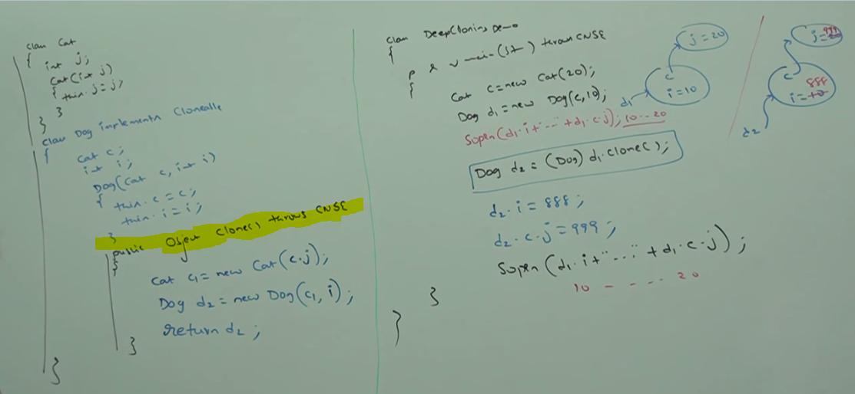

By using cloned object reference, if we perform any change to the content object then those changes won’t be reflected to main object.

If the Object contains only primitive variable then shallow cloning is the best choice. If object contains any reference variable. Then deep cloning is best choice.

**Wrapper Class:**

The main objectives of Wrapper classes are:

1. To wrap primitive into object form so that we can handle primitive also just like objects.
2. To define several utility methods which are required for the primitives.

Almost all Wrapper classes contains 2 constructors.

1. Take corresponding primitive as argument
2. Take String as argument

Ex: Integer I = new Integer (10);

Integer i1 = new Integer (“10”);

Float class contains 3 constructors. With Float, Double and String arguments.

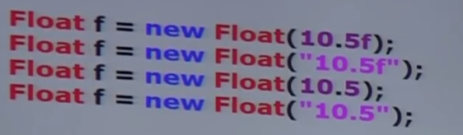

Character class contains only one constructor which can take char argument.

Char ch = new Char (‘a’);

**Boolean**

If we are passing String type as argument then case and content both are not important. If the content is case insensitive String of “true” then it is treated as true. Otherwise, it is treated as false.

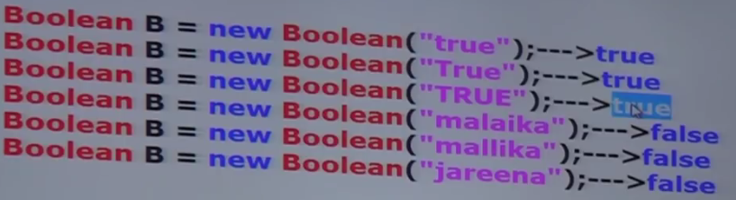

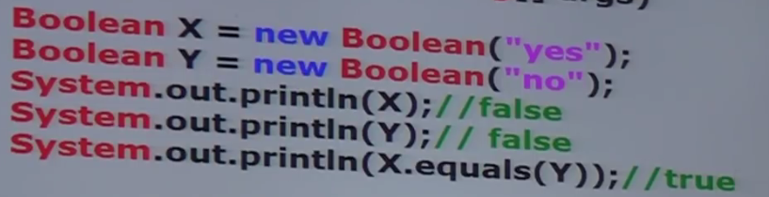

Wrapper class and corresponding Constructor arguments:

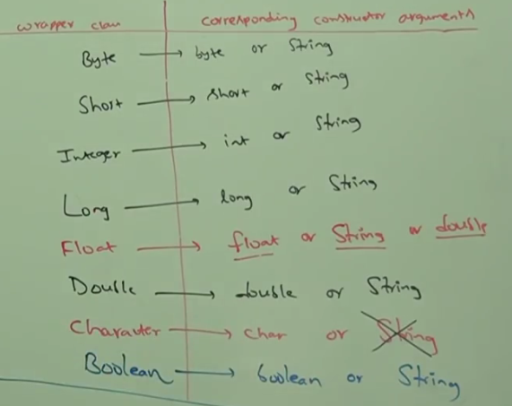

In all wrapper classes toString () method is overridden to return content directly.

In all wrapper classes .equals() method is overridden for content comparison.

**Utility methods:**

1. valueOf () 🡪 We can use valueOf () methods to create wrapper object for the given primitive or String.

Every wrapper class except character class contains a static value of method to create wrapper object for the given String.

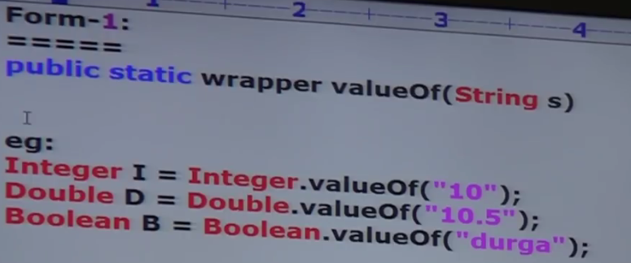

1. Every integral type Wrapper class (Byte, Short, Integer, Long) contains the following valueOf method to create Wrapper Object for the given specified radix String.

Public static wrapper valueOf (String s, int radix);

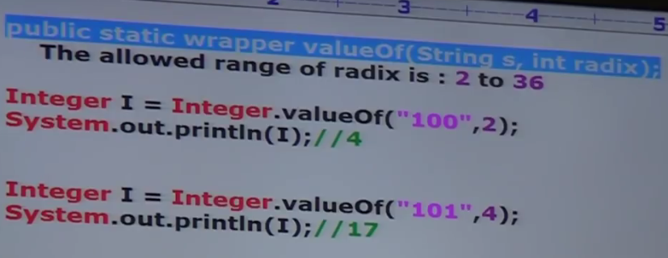

1. Every Wrapper class including character class contains a static valueOf method to create wrapper object for the given primitive.

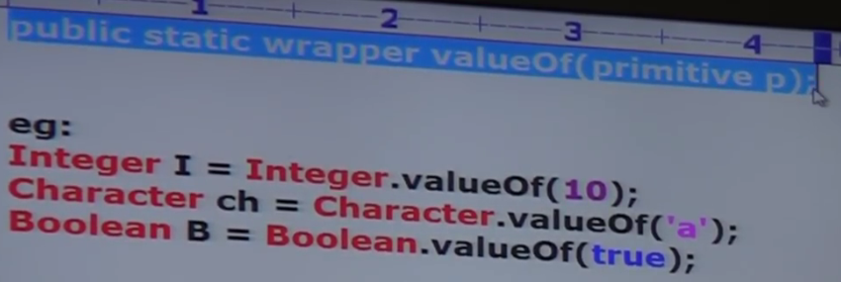

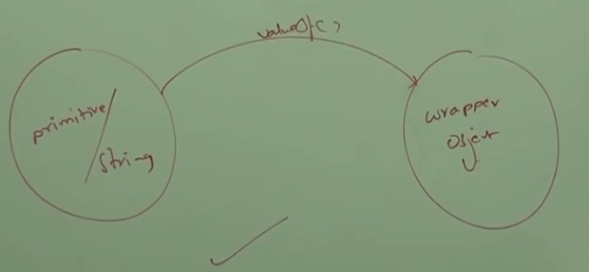

We can use xxxValue() to get primitive for the given wrapper object.

Every number type wrapper class (Byte, Short, Inter,Float, Double) has followimg methods

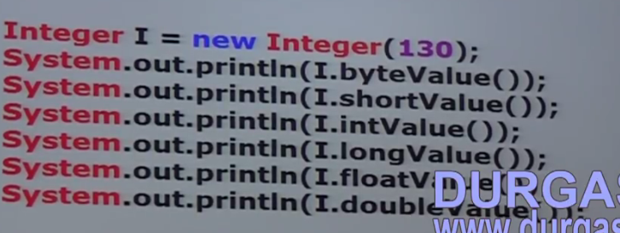

Character class contains charValue() method to get char primitive for the given character object.

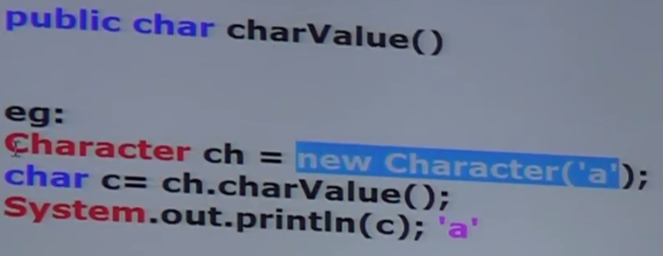

Boolean class contains booleanValue method to get boolean primitive for the given Boolean Object

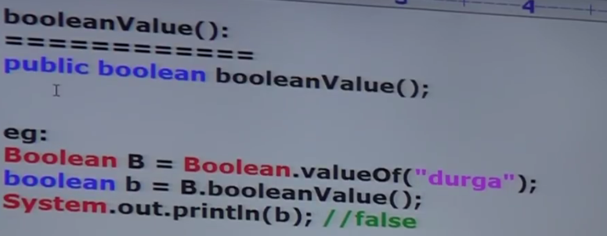

In total 38 (6*6+1+1) xxxValue() methods are possible.

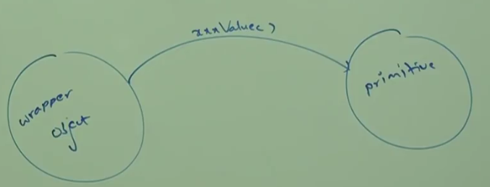

**To convert String to Primitive:**

Every Wrapper class except Character class contains the following parseXXX method to find primitive for the given String object.

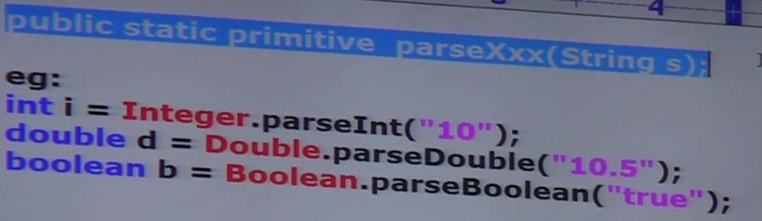

Every Integral type wrapper class (Byte, Short, Integer, Long) contains the following parseXXX method to convert specified radix String to Primitive.

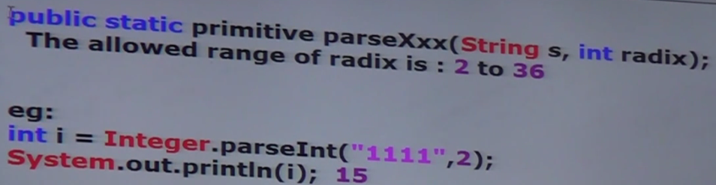

**To convert wrapper object/primitive to String:**

Every wrapper class contains the following toString() to convert wrapper object to String

1. Public String toString ()🡪It is the overriding version of Object class toString method.

Whenever we are trying to print wrapper object reference internally this toString method will be called.

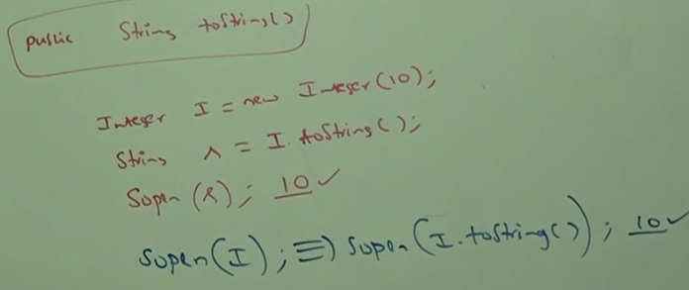

1. Every Wrapper class including character class contains the following static toString method to convert Primitive to String:

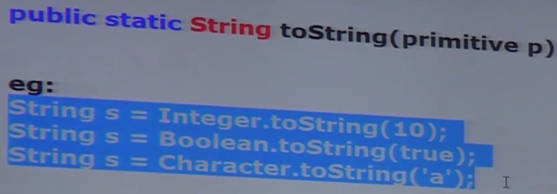

1. Integer and Long classes contains the following toString method to convert primitive to specified radix String.

Public static String toString (Primitive,int radix)

String s = Integer.toString(15,2)🡪1111

1. toXXXString ()

Integer and Long classes contains the following toXXXString methods

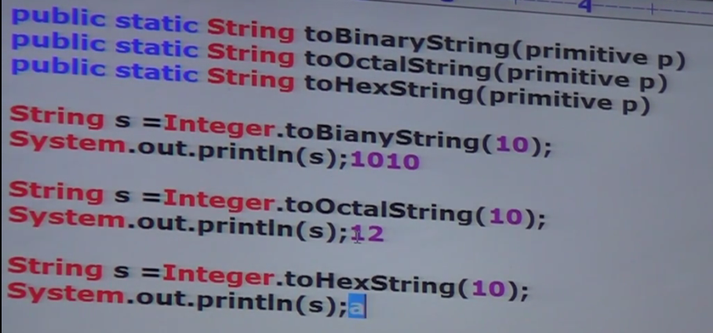

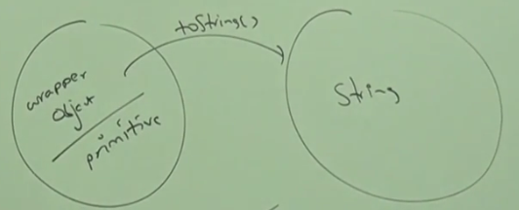

**Conversion between String, Wrapper Class and Primitive:**

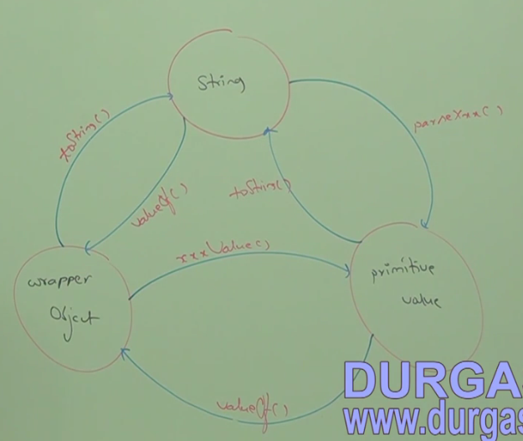

Partial Hierarchy of Object Class:

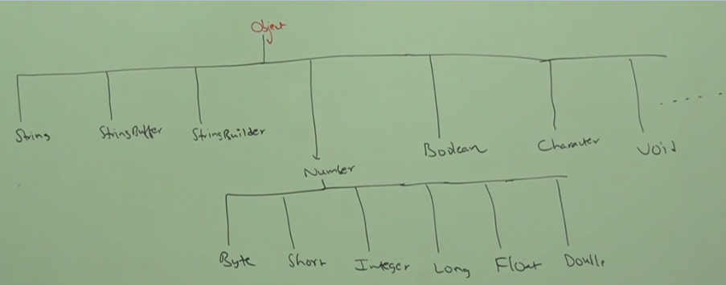

1. The wrapper classes which are not child class of Number are:

Boolean and Character

1. Wrapper classes which are not direct child class of Object are:

Byte,Short,Integer,Long,Float,Double

1. String, StringBuffer, StringBuilder and all Wrapper classes are final classes.
2. In addition to String Object all wrapper class object also immutable.

**Void class:**

It is a final class and it is the direct child class of Object. It does not contain ant methods and it contains only one variable Void.TYPE

In general, we can use void class in reflections to check whether the method return type is void or not.

If(getMethod(“m1”).getReturnType() == Void.TYPE){

====

}

Void is the class representation of void keyword in Java

**Autoboxing**:

Automatic conversion of primitive to wrapper object by compiler is called Autoboxing.

Integer i=10;//Compiler converts into to Integer automatically.

**Auto Unboxing**:

Automatic conversion of wrapper object to primitive by compiler is called Auto Unboxing.

Integer i= new Integer (10);

Int x =I;// compiler converts Integer to int automatically by Auto unboxing.

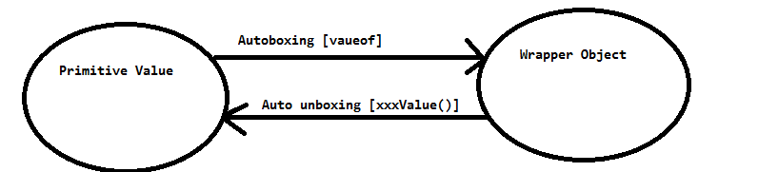

How to compile a class in a specific version:

**javac -source 1.4 Test.java**

On Null reference if we are trying to perform auto unboxing then we will get Runtime Exception saying NPE.

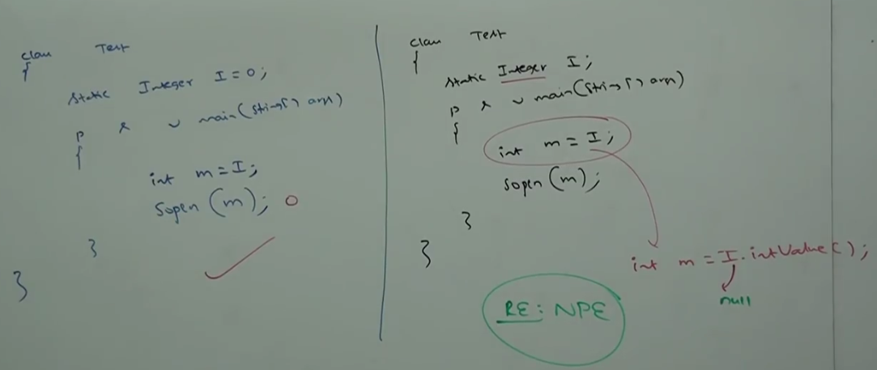

**All Wrapper class objects are immutable** i.e. once we create wrapper class object we can’t perform any changes in that Object. If we are trying to perform any changes with those changes a new Object will be created.

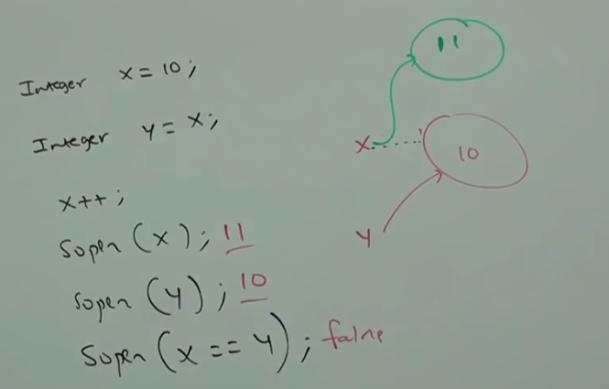

**Object Equality concept: Very Very Important**

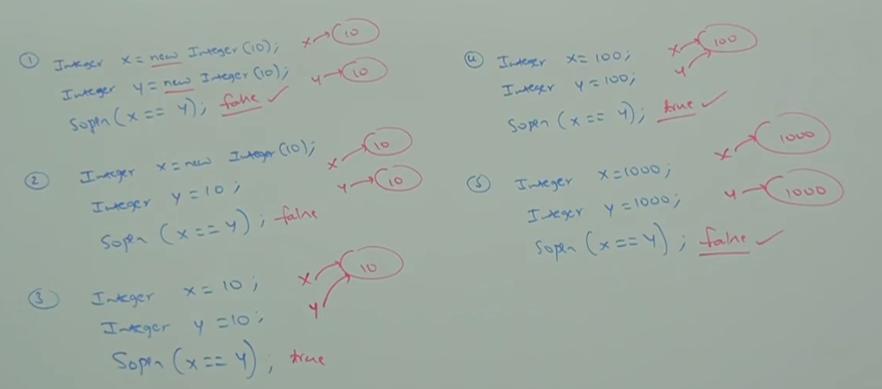

Internally to provide support for auto boxing a buffer of wrapper objects will be created at the time of wrapper class loading. By auto boxing if an object is required to create then first JVM will check whether the object is already present in the buffer or not. If it is already present in the buffer then existing buffer object will be used.

If it is not already available in the buffer then JVM will create a new Object.

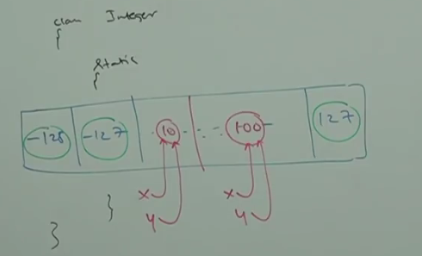

Bur buffer concept is available only in the following ranges:

Byte/Boolean ==Always

Short /Integer /Long ===-128 to 127

Character ====0 to 127

Except this range in all remaining cases a new Object will be created.

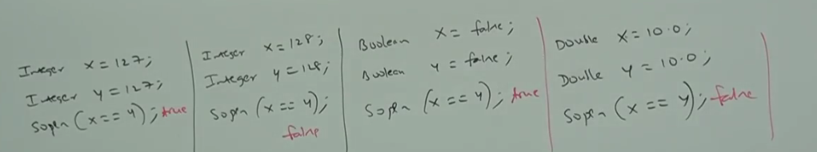

Internally auto boxing concept is implemented by using valueOf method. Hence, Buffer concept is applicable for valueOf () method also.

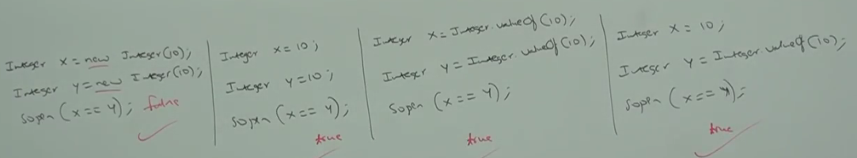

**Overloading with respect to Auto-Boxing**

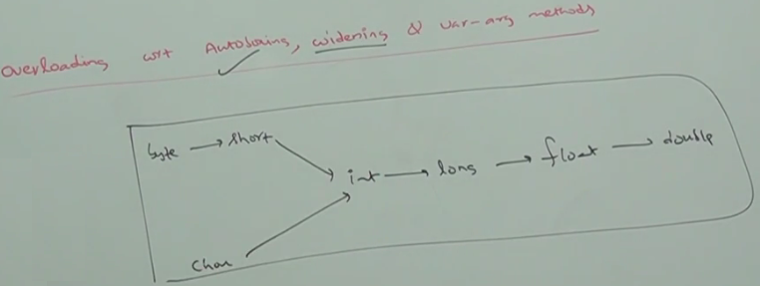

**Case1: Autoboxing vs widening---Widening dominates Autoboxing**

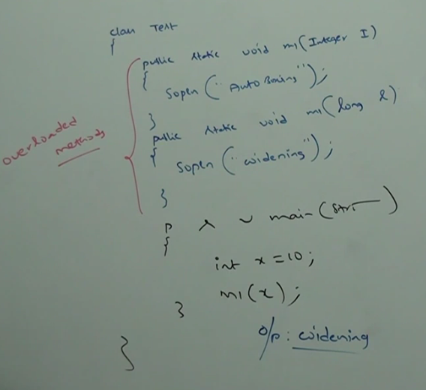

**Case2: Widening Vs Var args= Widening dominates Var args**

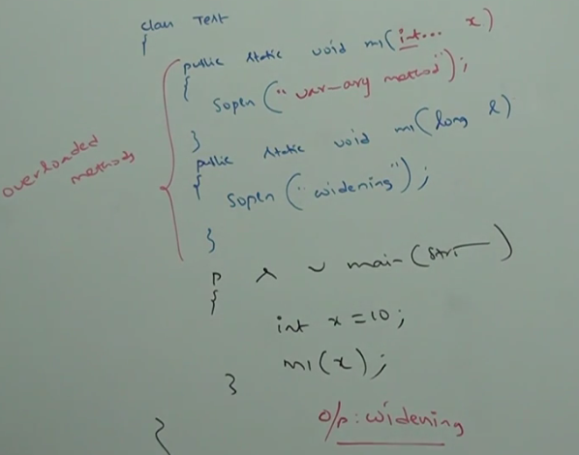

**Case3: Autoboxing vs Var args Autoboxing dominates Var args**

In general, var arg method will get least priority. If no other method matched then only var arg method will get the chance. It is exactly same as default case inside Switch.

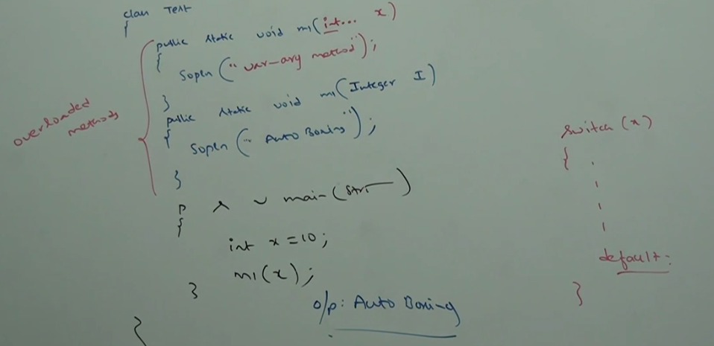

**Note*: While resolving overloaded methods compiler will always give the precedence in the following order:**

1. **Widening**
2. **Autoboxing**
3. **Var arg methods**

**Case4:**

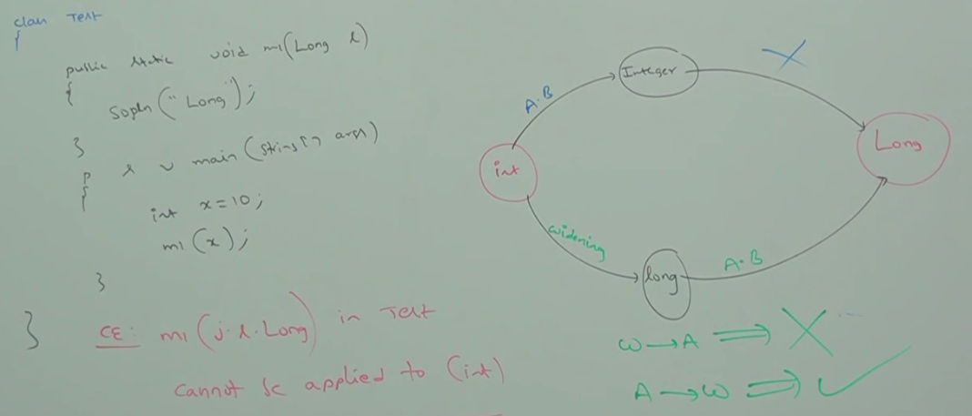

Widening followed by autoboxing is not allowed in java. Whereas, Autoboxing followed by widening is allowed.

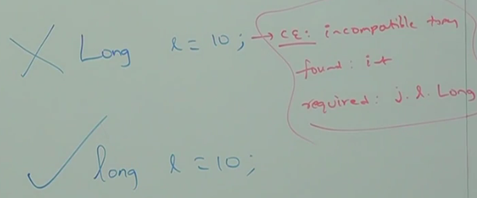

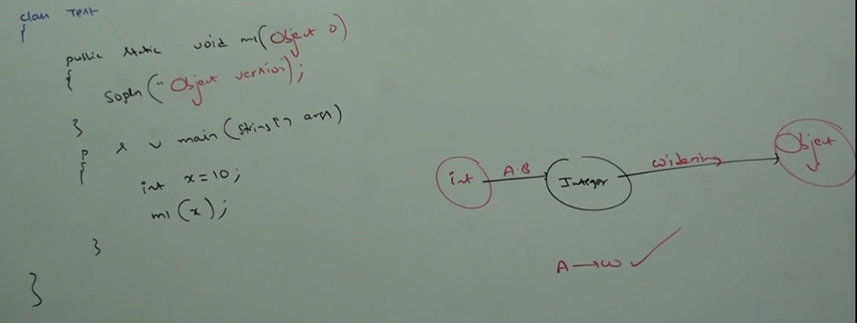

Autoboxing followed by widening is allowed.

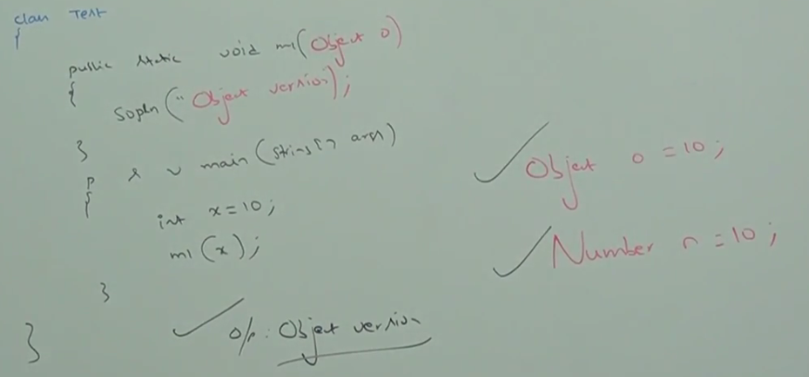

Integer I =10 (Autoboxing)

int i = 10L (CE: Possible loss of precision. Found long required int)

Long l = 10L; (Autoboxing);

Long l=10;(CE: Incompatible type. Found int required Long)

long l=10;(Widening)

Object o =10; (Autoboxing followed by Widening)

double d=10; (Widening)

Double D =10; (CE: Incompatible type. Found int required Double)

Number n=10; (AB followed by Widening)